UNIT-VIII
SPECIAL PURPOSE ELECTRONIC DEVICES

8.1 PRINCIPLE OF OPERATION AND CHARACTERISTICS OF TUNNEL DIODE
8.2 VARACTOR DIODE
8.3 SCHOTTKY DIODE

8.4 PRINCIPLE OF OPERATION OF SCR

8.5 PHOTO DIODE

UNIT-VIII
SPECIAL PURPOSE ELECTRONIC DEVICES

- 8.1 PRINCIPLE OF OPERATION AND CHARACTERISTICS OF TUNNEL DIODE:
A tunnel diode or Esaki diode is a type of semiconductor diode which is capable of very fast operation, well into the microwave frequency region, by using quantum mechanical effects.
It was invented in August 1957 by Leo Esaki when he was with Tokyo Tsushin Kogyo, now known as Sony. In 1973 he received the Nobel Prize in Physics, jointly with Brian Josephson, for discovering the electron tunneling effect used in these diodes. Robert Noyce independently came up with the idea of a tunnel diode while working for William Shockley, but was discouraged from pursuing it.
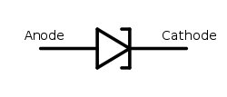
Fig:Tunnel diode schematic symbol
These diodes have a heavily doped p–n junction only some 10 nm (100 Å) wide. The heavy doping results in a broken bandgap, where conduction band electron states on the n-side are more or less aligned with valence band hole states on the p-side.
Tunnel diodes were manufactured by Sony for the first time in 1957 followed by General Electric and other companies from about 1960, and are still made in low volume today. Tunnel diodes are usually made from germanium, but can also be made in gallium arsenide and silicon materials. They can be used as oscillators, amplifiers, frequency converters and detectors.
Tunnelling Phenomenon:
In a conventional semiconductor diode, conduction takes place while the p–n junction is forward biased and blocks current flow when the junction is reverse biased. This occurs up to a point known as the “reverse breakdown voltage” when conduction begins (often accompanied by destruction of the device). In the tunnel diode, the dopant concentration in the p and n layers are increased to the point where the reverse breakdown voltage becomes zero and the diode conducts in the reverse direction. However, when forward-biased, an odd effect occurs called “quantum mechanical tunnelling” which gives rise to a region where an increase in forward voltage is accompanied by a decrease in forward current. This negative resistance region can be exploited in a solid state version of the dynatron oscillator which normally uses a tetrode thermionic valve (or tube).

Forward bias operation
Under normal forward bias operation, as voltage begins to increase, electrons at first tunnel through the very narrow p–n junction barrier because filled electron states in the conduction band on the n-side become aligned with empty valence band hole states on the p-side of the p-n junction. As voltage increases further these states become more misaligned and the current drops – this is called negative resistance because current decreases with increasing voltage. As voltage increases yet further, the diode begins to operate as a normal diode, where electrons travel by conduction across the p–n junction, and no longer by tunneling through the p–n junction barrier. Thus the most important operating region for a tunnel diode is the negative resistance region.

Reverse bias operation
When used in the reverse direction they are called back diodes and can act as fast rectifiers with zero offset voltage and extreme linearity for power signals (they have an accurate square law characteristic in the reverse direction).
Under reverse bias filled states on the p-side become increasingly aligned with empty states on the n-side and electrons now tunnel through the pn junction barrier in reverse direction – this is the Zener effect that also occurs in zener diodes.

Technical comparisons
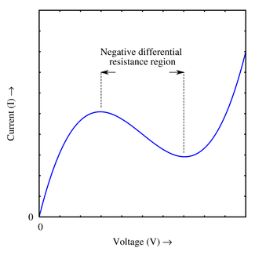

A rough approximation of the VI curve for a tunnel diode, showing the negative differential resistance region.The Japanese physicist Leo Esaki invented the tunnel diode in 1958.It consists of a p-n junction with highly doped regions. Because of the thinness of the junction, the electrons can pass through the potential barrier of the dam layer at a suitable polarization, reaching the energy states on the other sides of the junction. The current-voltage characteristic of the diode is represented in Figure 1. In this sketch i p and Up are the peak, and iv and Uv are the valley values for the current and voltage respectively. The form of this dependence can be qualitatively explained by considering the tunneling processes that take place in a thin p-n junction.

Energy band structure of tunnel diode: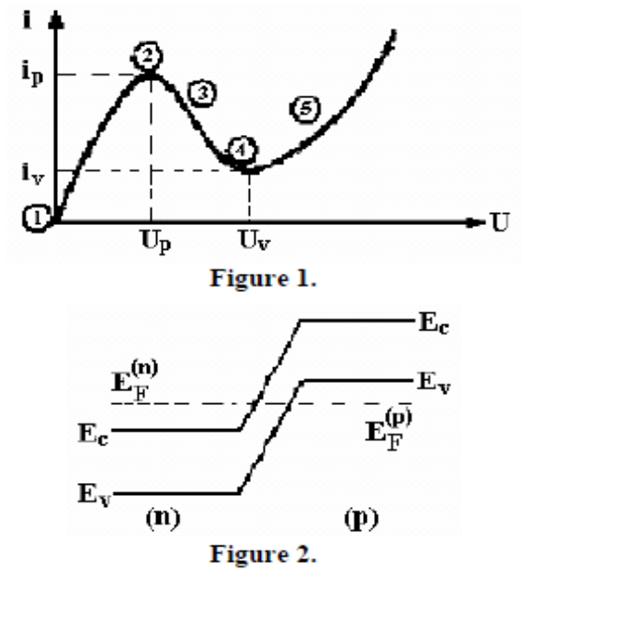

For the degenerated semiconductors, the energy band diagram at thermal equilibrium is presented in Figure 2.

In Figure 3 the tunneling processes in different points of the current voltage characteristic for the tunnel diode are presented.
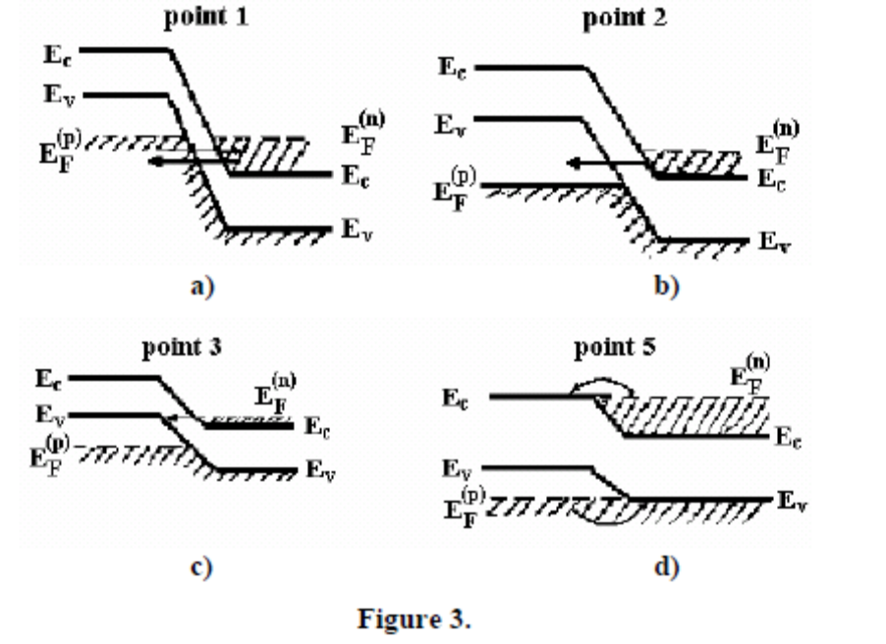

In Fig. 3a, the thermal equilibrium situation corresponding to point 1
from the Fig. 1 diagram presented; in this case the electrons will uniformly tunnel in both directions, so the current will be null. At a direct polarization, a non-zero electron flow will tunnel from the occupied states of the conduction band of the n region to the empty states
of the valence band from the p region. The current attains a maximum when the overlap of the empty and occupied states reaches the maximum value; a minimum value is reached when there are no states for tunneling on the sides of the barrier. In this case, the tunnel current should drop to zero.

Advantages of tunnel diodes:
- Environmental immunity i.e peak point is not a function of temperature.
- low cost.
- low noise.
- low power consumption.
- High speed i.e tunneling takes place very fast at the speed of light in the order of nanoseconds
- simplicity i.e a tunnel diode can be used along with a d.c supply and a few passive elements to obtain various application circuits.
Applications for tunnel diodes:
- local oscillators for UHF television tuners
- Trigger circuits in oscilloscopes
- High speed counter circuits and very fast-rise time pulse generator circuits
- The tunnel diode can also be used as low-noise microwave amplifier.
8.2 VARACTOR DIODE:

Varactor diode is a special type of diode which uses transition capacitance property i.e voltage variable capacitance .These are also called as varicap,VVC(voltage variable capacitance) or tuning diodes.
The varactor diode symbol is shown below with a diagram representation.
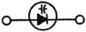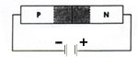
Fig:symbol of varactor diode
When a reverse voltage is applied to a PN junction , the holes in the p-region are attracted to the anode terminal and electrons in the n-region are attracted to the cathode terminal creating a region where there is little current.This region ,the depletion region, is essentially devoid of carriers and behaves as the dielectric of a capacitor.
The depletion region increases as reverse voltage across it increases; and since capacitance varies inversely as dielectric thickness, the junction capacitance will decrease as the voltage across the PN junction increases. So by varying the reverse voltage across a PN junction the junction capacitance can be varied .This is shown in the typical varactor voltage-capacitance curve below.
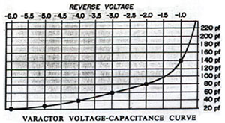
Fig:voltage- capacitance curve
Notice the nonlinear increase in capacitance as the reverse voltage is decreased. This nonlinearity allows the varactor to be used also as a harmonic generator.
Major varactor considerations are:
(a) Capacitance value
(b) Voltage
(c) Variation in capacitance with voltage.
(d) Maximum working voltage
(e) Leakage current
Applications:
  - Tuned circuits.
  - FM modulators
  - Automatic frequency control devices
  - Adjustable bandpass filters
  - Parametric amplifiers
  - Television receivers.
8.3 SCHOTTKY DIODE:
A Schottky diode is a majority carrier device, where electron-hole recombination is usually not important. Hence, Schottky diodes have a much faster response under forward bias conditions than p-n junction diodes. Therefore, Schottky diodes are used in applications where the speed of a response is important, for example, in microwave detectors, mixers, and varactors. schottky diodes are specially manufactured to solve the problem of fast switching which consists of a metal to semiconductor junction.The symbol of schottky diode is as follows:
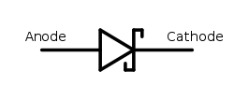
Fig:symbol of schottky diode

Structure and principle of operation

1. Structure
The structure of a metal-semiconductor junction is shown in Figure 1. It consists of a metal contacting a piece of semiconductor. An ideal Ohmic contact, a contact such that no potential exists between the metal and the semiconductor, is made to the other side of the semiconductor. The sign convention of the applied voltage and current is also shown on Figure 1.

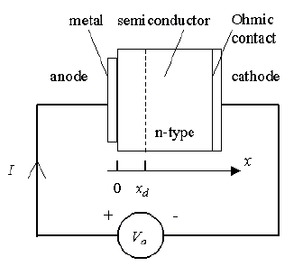
Figure 1 : Structure and sign convention of a metal-semiconductor junction

Flatband diagram and built-in potential

The barrier between the metal and the semiconductor can be identified on an energy band diagram. To construct such diagram we first consider the energy band diagram of the metal and the semiconductor, and align them using the same vacuum level as shown in Figure 2 (a). As the metal and semiconductor are brought together, the Fermi energies of the metal and the semiconductor do not change right away. This yields the flatband diagram of Figure 2 (b).

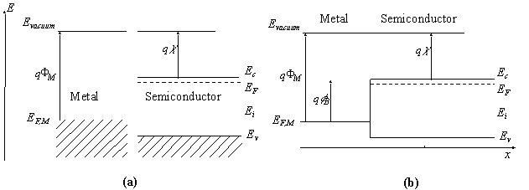

Figure 2 : | Energy band diagram of the metal and the semiconductor before (a) and after (b) contact is made.

The barrier height, _{B}, is defined as the potential difference between the Fermi energy of the metal and the band edge where the majority carriers reside. From Figure 2 (b) one finds that for an n-type semiconductor the barrier height is obtained from:

(1.1)

Where _{M} is the work function of the metal and  is the electron affinity. The work function of selected metals as measured in vacuum can be found in Table 1. For p-type material, the barrier height is given by the difference between the valence band edge and the Fermi energy in the metal:

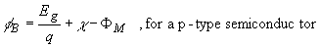 | (1.2)

A metal-semiconductor junction will therefore form a barrier for electrons and holes if the Fermi energy of the metal as drawn on the flatband diagram is somewhere between the conduction and valence band edge.

In addition, we define the built-in potential, _{I}, as the difference between the Fermi energy of the metal and that of the semiconductor.

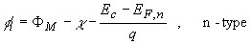 | (1.3)

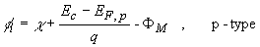 | (1.4)

Energy band diagram of a metal-semiconductor contact in thermal equilibrium.

The flatband diagram, shown in Figure 2 (b), is not a thermal equilibrium diagram, since the Fermi energy in the metal differs from that in the semiconductor. Electrons in the n-type semiconductor can lower their energy by traversing the junction. As the electrons leave the semiconductor, a positive charge, due to the ionized donor atoms, stays behind. This charge creates a negative field and lowers the band edges of the semiconductor. Electrons flow into the metal until equilibrium is reached between the diffusion of electrons from the semiconductor into the metal and the drift of electrons caused by the field created by the ionized impurity atoms. This equilibrium is characterized by a constant Fermi energy throughout the structure.

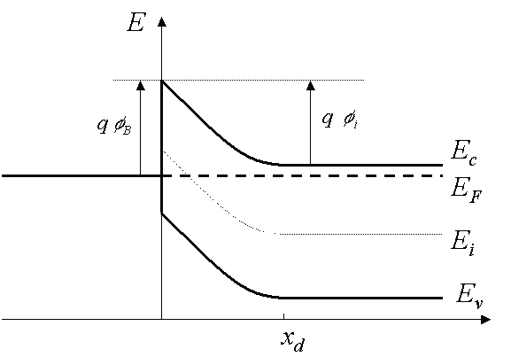

Figure 3 : | Energy band diagram of a metal-semiconductor contact in thermal equilibrium.

It is of interest to note that in thermal equilibrium, i.e. with no external voltage applied, there is a region in the semiconductor close to the junction which is depleted of mobile carriers. We call this the depletion region. The potential across the semiconductor equals the built-in potential

Forward and reverse bias

Operation of a metal-semiconductor junction under forward and reverse bias is illustrated with Figure 4. As a positive bias is applied to the metal (Figure 4 (a)), the Fermi energy of the metal is lowered with respect to the Fermi energy in the semiconductor. This results in a smaller potential drop across the semiconductor. The balance between diffusion and drift is disturbed and more electrons will diffuse towards the metal than the number drifting into the semiconductor. This leads to a positive current through the junction at a voltage comparable to the built-in potential.

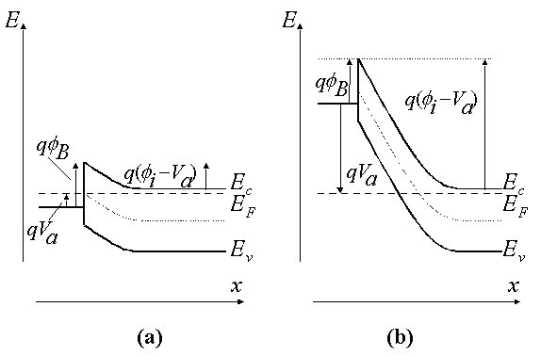

Figure 4 : | Energy band diagram of a metal-semiconductor junction under (a) forward and (b) reverse bias

As a negative voltage is applied (Figure 4 (b)), the Fermi energy of the metal is raised with respect to the Fermi energy in the semiconductor. The potential across the semiconductor now increases, yielding a larger depletion region and a larger electric field at the interface. The barrier, which restricts the electrons to the metal, is unchanged so that the flow of electrons is limited by that barrier independent of the applied voltage. The metal-semiconductor junction with positive barrier height has therefore a pronounced rectifying behavior. A large current exists under forward bias, while almost no current exists under reverse bias.
Characteristics of Schottky Diode:
Due to minority carrier free region, schottky diode cannot store the charge.Hence due to lack of charge storage,it can switch off very fast than a conventional diode.it can be easily switched off for the frequencies above 300MHz.The barrier at the junction for a schottky diode is less than that of normal p-n diode in both forward and reverse bias region.The barrier potential and breakdown voltage in forward bias and reverse bias region respectively are also less than p-n junction diode.The barrier potential is 0.25V as compared to 0.7V for normal diode.
Applications:
Due to fast switching characteristics this diode is very useful for high frequency applications such as digital computer,high speed TTl,radar systems,mixers,detectors in communication equipments and analog to digital converters.

8.4 PRINCIPLE OF OPERATION OF SCR
A silicon-controlled rectifier (or semiconductor-controlled rectifier) is a four-layer solid state device that controls current. The name "silicon controlled rectifier" or SCR is General Electric's trade name for a type of thyristor. The SCR was developed by a team of power engineers led by Gordon Hall and commercialized by Frank W. "Bill" Gutzwiller in 1957.symbol of SCR is given below:

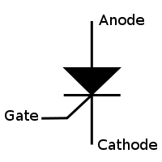

Fig : symbol of SCR

Construction of SCR
An SCR consists of four layers of alternating P and N type semiconductor materials. Silicon is used as the intrinsic semiconductor, to which the proper dopants are added. The junctions are either diffused or alloyed. The planar construction is used for low power SCRs (and all the junctions are diffused). The mesa type construction is used for high power SCRs. In this case, junction J2 is obtained by the diffusion method and then the outer two layers are alloyed to it, since the PNPN pellet is required to handle large currents. It is properly braced with tungsten or molybdenum plates to provide greater mechanical strength. One of these plates is hard soldered to a copper stud, which is threaded for attachment of heat sink. The doping of PNPN will depend on the application of SCR, since its characteristics are similar to those of the thyratron. Today, the term thyristor applies to the larger family of multilayer devices that exhibit bistable state-change behaviour, that is, switching either ON or OFF.
The operation of a SCR and other thyristors can be understood in terms of a pair of tightly coupled bipolar junction transistors, arranged to cause the self-latching action.The following figures are construction of SCR,its two transistor model and symbol respectively
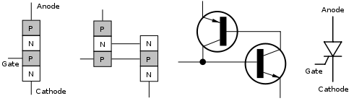

Fig: Construction,Two transistor model of SCR and symbol of SCR

. SCR Working Principle

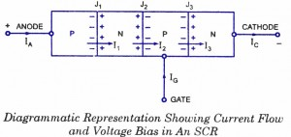
The SCR is a four-layer, three-junction and a three-terminal device and is shown in fig.a. The end P-region is the anode, the end N-region is the cathode and the inner P-region is the gate. The anode to cathode is connected in series with the load circuit. Essentially the device is a switch. Ideally it remains off (voltage blocking state), or appears to have an infinite impedance until both the anode and gate terminals have suitable positive voltages with respect to the cathode terminal. The thyristor then switches on and current flows and continues to conduct without further gate signals. Ideally the thyristor has zero impedance in conduction state. For switching off or reverting to the blocking state, there must be no gate signal and the anode current must be reduced to zero. Current can flow only in one direction.
In absence of external bias voltages, the majority carrier in each layer diffuses until there is a built-in voltage that retards further diffusion. Some majority carriers have enough energy to cross the barrier caused by the retarding electric field at each junction. These carriers then become minority carriers and can recombine with majority carriers. Minority carriers in each layer can be accelerated across each junction by the fixed field, but because of absence of external circuit in this case the sum of majority and minority carrier currents must be zero.
A voltage bias, as shown in figure, and an external circuit to carry current allow internal currents which include the following terms:
The current I_{x} is due to
- Majority carriers (holes) crossing junction J₁
- Minority carriers crossing junction J₁
- Holes injected at junction J₂ diffusing through the N-region and crossing junction J₁ and
- Minority carriers from junction J₂ diffusing through the N-region and crossing junction J₁.
V I characteristics of SCR:

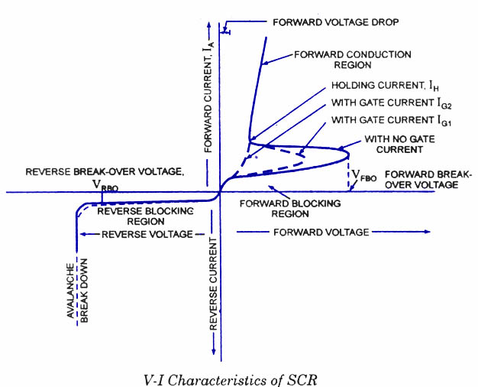
As already mentioned, the SCR is a four-layer device with three terminals, namely, the anode, the cathode and the gate. When the anode is made positive with respect to the cathode, junctions J₁ and J₃ are forward biased and junction J₂ is reverse-biased and only the leakage current will flow through the device. The SCR is then said to be in the forward blocking state or in the forward mode or off state. But when the cathode is made positive with respect to the anode, junctions J₁ and J₃ are reverse-biased, a small reverse leakage current will flow through the SCR and the SGR is said to be in the reverse blocking state or in reverse mode.
When the anode is positive with respect to cathode i.e. when the SCR is in forward mode, the SCR does not conduct unless the forward voltage exceeds certain value, called the forward breakover voltage, V_{FB0}. In non-conducting state, the current through the SCR is the leakage current which is very small and is negligible. If a positive gate current is supplied, the SCR can become conducting at a voltage much lesser than forward break-over voltage. The larger the gate current, lower the break-over voltage. With sufficiently large gate current, the SCR behaves identical to PN rectifier. Once the SCR is switched on, the forward voltage drop across it is suddenly reduced to very small value, say about 1 volt. In the conducting or on-state, the current through the SCR is limited by the external impedance.
When the anode is negative with respect to cathode, that is when the SCR is in reverse mode or in blocking state no current flows through the SCR except very small leakage current of the order of few micro-amperes. But if the reverse voltage is increased beyond a certain value, called the reverse break-over voltage, V_{RB0} avalanche break down takes place. Forward break-over voltage V_{FB0} is usually higher than reverse breakover voltage,V_{RBO.}
From the foregoing discussion, it can be seen that the SCR has two stable and reversible operating states. The change over from off-state to on-state, called turn-on, can be achieved by increasing the forward voltage beyond V_{FB0}. A more convenient and useful method of turn-on the device employs the gate drive. If the forward voltage is less than the forward break-over voltage, V_{FB0}, it can be turned-on by applying a positive voltage between the gate and the cathode. This method is called the gate control. Another very important feature of the gate is that once the SCR is triggered to on-state the gate loses its control.
The switching action of gate takes place only when
(i) SCR is forward biased i.e. anode is positive with respect to cathode, and
(ii) Suitable positive voltage is applied between the gate and the cathode.
Once the SCR has been switched on, it has no control on the amount of current flowing through it. The current through the SCR is entirely controlled by the external impedance connected in the circuit and the applied voltage. There is, however, a very small, about 1 V, potential drop across the SCR. The forward current through the SCR can be reduced by reducing the applied voltage or by increasing the circuit impedance. There is, however, a minimum forward current that must be maintained to keep the SCR in conducting state. This is called the holding current rating of SCR. If the current through the SCR is reduced below the level of holding current, the device returns to off-state or blocking state.
The SCR can be switched off by reducing the forward current below the level of holding current which may be done either by reducing the applied voltage or by increasing the circuit impedance.
Note : The gate can only trigger or switch-on the SCR, it cannot switch off.
Alternatively the SCR can be switched off by applying negative voltage to the anode (reverse mode), the SCR naturally will be switched off.
Here one point is worth mentioning, the SCR takes certain time to switch off. The time, called the turn-off time, must be allowed before forward voltage may be applied again otherwise the device will switch-on with forward voltage without any gate pulse. The turn-off time is about 15 micro-seconds, which is immaterial when dealing with power frequency, but this becomes important in the inverter circuits, which are to operate at high frequency.

Merits of SCR

1.Very small amount of gate drive is required.
2.SCRs with high voltage and current ratings are available.
3.On state losses of SCR are less.

Demerits of SCR

1.Gate has no control,once SCR is turned on.
2.External circuits are required for turning it off.
3.Operationg frequencies are low.
4.Additional protection circuits are required.
Application of SCRs
SCRs are mainly used in devices where the control of high power, possibly coupled with high voltage, is demanded. Their operation makes them suitable for use in medium to high-voltage AC power control applications, such as lamp dimming, regulators and motor control.
SCRs and similar devices are used for rectification of high power AC in high-voltage direct current power transmission

8.5 PHOTO DIODE:

The photo diode is a semiconductor p-n junction device whose region of operation is limited to the reverse biased region.The figure below shows the symbol of photodiode
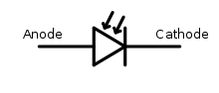

Fig:Symbol for photodiode.

Principle of operation:
A photodiode is a type of photo detector capable of converting light into either current or voltage, depending upon the mode of operation. The common, traditional solar cell used to generate electric solar power is a large area photodiode. A photodiode is designed to operate in reverse bias. The deletion region width is large.Under normal conditions it carries small reverse current due to minority charge carriers.When light is incident through glass window on the p-n junction,photons in the light bombard the p-n junction and some energy s imparted to the valence electrons.So valence electrons break covalent bonds and become free electrons.Thus more electron-hole pairs are generated.Thus total number of minority charge carriers increases and hence reverse current increases.This is the basic principle of operation of photo diode.
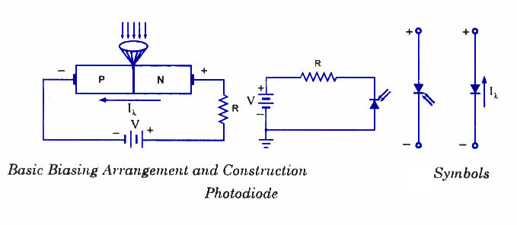

Characteristics of photodiode:
When the P-N junction is reverse-biased, a reverse saturation current flows due to thermally generated holes and electrons being swept across the junction as the minority carriers. With the increase in temperature of the junction more and more hole-electron pairs are created and so the reverse saturation current I₀ increases. The same effect can be had by illuminating the junction. When light energy bombards a P-N junction, it dislodges valence electrons. The more light striking the junction the larger the reverse current in a diode. It is due to generation of more and more charge carriers with the increase in level of illumination. This is clearly shown in ‘ figure for different intensity levels. The dark current is the current that exists when no light is incident. It is to be noted here that current becomes zero only with a positive applied bias equals to V_{Q}. The almost equal spacing between the curves for the same increment in luminous flux reveals that the reverse saturation current I₀ increases linearly with the luminous flux as shown in figure. Increase in reverse voltage does not increase the reverse current significantly, because all available charge carriers are already being swept across the junction. For reducing the reverse saturation current I₀ to zero, it is necessary to forward bias the junction by an amount equal to barrier potential. Thus the photodiode can be used as a photoconductive device.
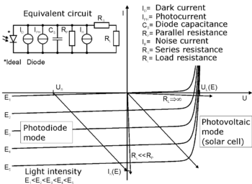
Fig: characteristics of photodiode
On removal of reverse bias applied across the photodiode, minority charge carriers continue to be swept across the junction while the diode is illuminated. This has the effect of increasing the concentration of holes in the P-side and that of electrons in the N-side But the barrier potential is negative on the P-side and positive on the N-side, and was created by holes flowing from P to N-side and electrons from N to P-side during fabrication of junction. Thus the flow of minority carriers tends to reduce the barrier potential.
When an external circuit is connected across the diode terminals, the minority carrier; return to the original side via the external circuit. The electrons which crossed the junction from P to N-side now flow out through the N-terminal and into the P-terminal This means that the device is behaving as a voltage cell with the N-side being the negative terminal and the P-side the positive terminal. Thus, the photodiode is & photovoltaic device as well as photoconductive device.

Advantages:
The advantages of photodiode are:
1.It can be used as variable resistance device.
2.Highly sensitive to the light.
3.The speed of operation is very high.

Disadvantages:
1.Temperature dependent dark current.
2.poor temperature stability.
3.Current needs amplification for driving other circuits.

Applications:

1.Alarm system.
2.counting system.

Problems:
1.In a particular application single phase half wave rectifier using SCR is used.The average load voltage is 80V.If supply voltage is 230V,50Hz a.c.find the firing angle of the SCR.
2.In a particular application single phase half wave rectifier using SCR s used.The supply voltage is 325sint where =100πrad/sec.Find the time for which SCR remains OFF if forward breakover voltage is 125V.

Important Questions:
1.Briefly discuss about photodiode.
2.Draw the basic structure of a varator diode and explain its characteristics.
3.Explain qualitatively the V-I characteristics of a tunnel diode.
4.Draw the basic structure of a SCR and explain its characteristics.

